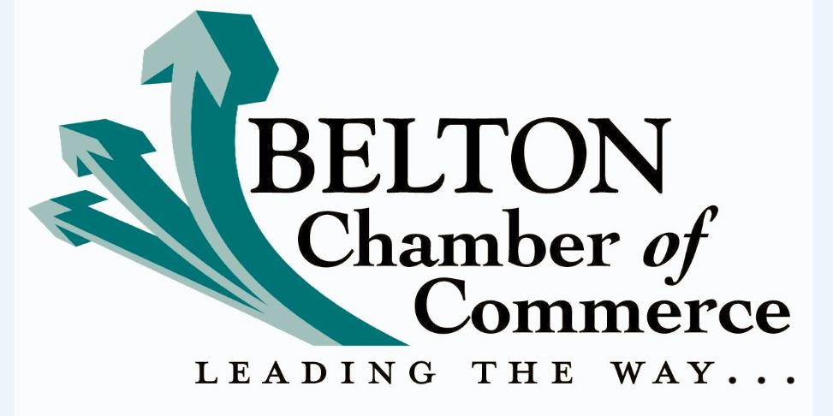
2017 BELTON CHAMBER OF COMMERCE GOLF TOURNAMENT
REGISTRATION FORM
TEAM $700 / INDIVIDUAL $175
NAME: _______________________________________________________________________________
CONTACT: ____________________________________________________________________________
NAME: _______________________________________________________________________________
CONTACT: ____________________________________________________________________________
NAME: _______________________________________________________________________________
CONTACT: ____________________________________________________________________________
NAME: _______________________________________________________________________________
CONTACT: ____________________________________________________________________________
PRESENTING SPONSOR $5,000 (1) - SOLD! MSE HARDSCAPES
CADDY SPONSOR $3,500 (1) ______________________________________________________________
EAGLE SPONSOR $2,000_________________________________________________________________
RANGE SPONSOR $1,500 (1) ______________________________________________________________
BEVERAGE CART SPONSOR $1,200 ________________________________________________________
BIRDIE SPONSOR $1,000 _________________________________________________________________
HOLE IN ONE SPONSOR $750 (4) __________________________________________________________
CONTEST SPONSOR $500 (4) _____________________________________________________________
TEE BOX SPONSOR $100 _________________________________________________________________

TOTAL AMOUNT DUE:
$____________________________________________________________________________________

THANK YOU!

